urbanism + landscape

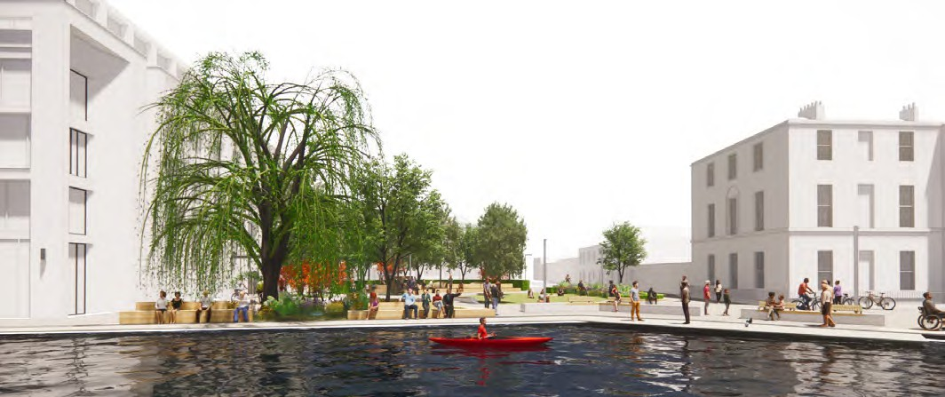
Portobello Harbour Park

Client: Dublin City Council. Site area: 0.3 hectares approx. Status: Part 8 June 2024
Budget: €1.5 million approx.
View from southern bank of the Grand Canal

Portobello Harbour Park will be a multi-functional and multi-generational public open space that will provide an attractive and verdant city space for people to relax, rest, play, socialise and experience nature. The design is the result of a 12 month process of co-design and consultation with the local community, City Councilors, stakeholder groups, local schools, Waterways Ireland and the departments of Dublin City Council.

The park is extended by closing an existing street (Richmond Row) to traffic and by integrating the existing cycle track into the park as a ‘Share with Care’ route. The design becomes more tranquil and green in close proximity to the existing housing and hotel while also being harder and more urban between the Lock Gates and Portobello House. A unique feature of the Park will be a deck and long seating on the Canal bank.

At its heart, the Park will have an open lawn area that will function as a green carpet for informal play and rest. It will also support occasional use for events and markets. The central lawn is enclosed to the north and west side with wide soft landscape zones that incorporate rain gardens, semi-mature trees
and pollinator-friendly planting and accommodate a range of play elements for imaginative play and exploration. The green component of the Park allows for the implementation of Nature-Based Solutions for dealing with stormwater runoff.

During the lengthy co-design and engagement process some members of the community expressed a wish for skateboarding to be excluded from the space. This however conflicted with a city-wide community of skateboarders who articulated the importance of Portobello as an accessible and safe destination for skateboarders in the city. Within this park; surfacing, kerbs and planting bed edges will be designed to be skateable. In the north and eastern areas of the Park in proximity to dwellings and the hotel; skateboarding will be discouraged and as required kerbs and furniture will be designed and adapted to preclude use by skateboarders.

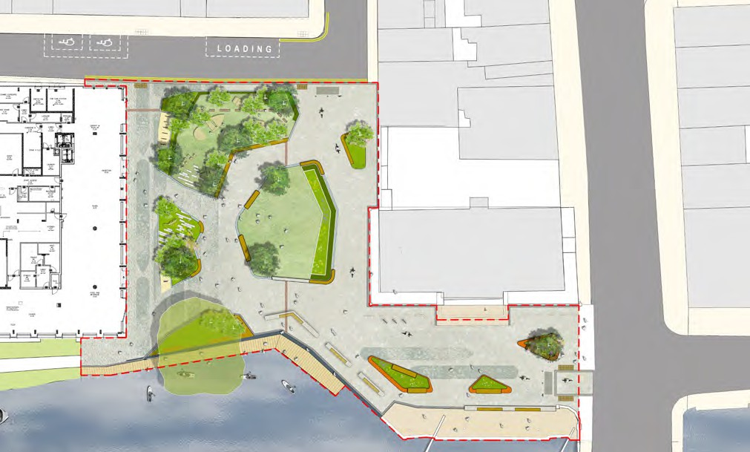
14

3

10

15

7
K E Y
- Incidental and natural play elements
- Hardwood seating
13
16
10
1
2
- Rain Garden
- Large specimen trees
- Existing Willow
- Lawn
7
9
3
11
6
11
4
- Pollinator friendly planting
- Raised corten steel planter
- Shared circulation area; pedestrian and cycle
2
5
8
11
16
0
10 m
12
Landscape Masterplan
- Cyclestands
- Skate friendly kerbing & raised edges
- Existing stone sett paving retained
- Hedging to separate play activity from street
- DAC set down space
- Stepping Stones through Rain Garden
- Cycle gateways to Park with ‘Share with Care’ signage.
N

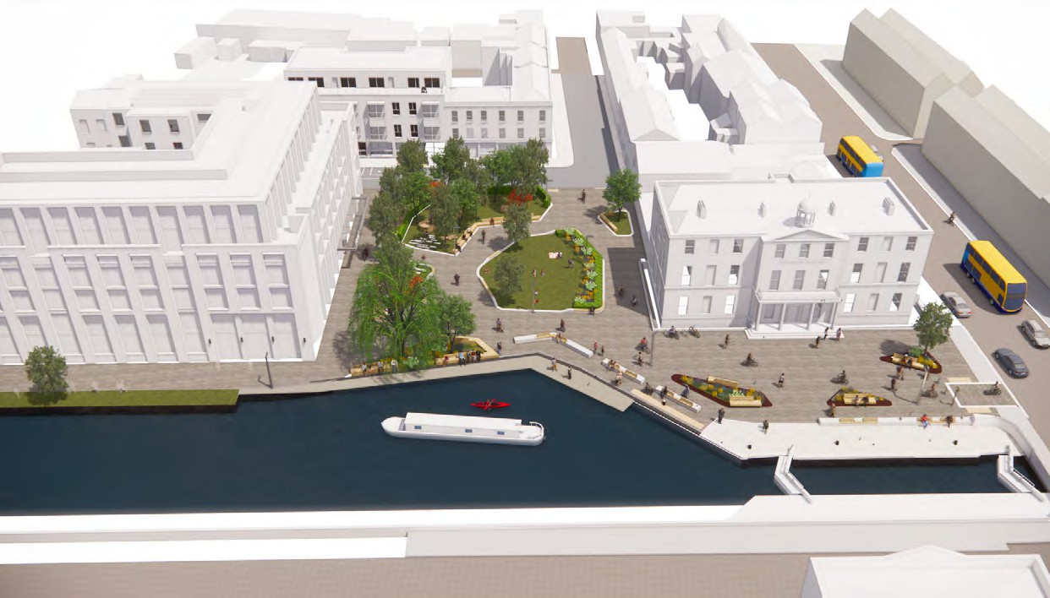
Birds-eye perspective

